**Exp. 7 Virtual Machine with 1 CPU, 2GB RAM and 15GB storage disk**

**Aim:**

To create a Virtual Machine with 1 CPU, 2GB RAM and 15GB storage disk using a Type 2 Virtualization Software, using virtual box.

**Procedure:**

* Open virtual box application
* Then click on new button to create a new VM
* Enter the name and select the required ISO file
* Enter credentials like username and password
* Select required hard disk size and memory size, along with number of CPUs
* Now the VM is created

**Output:**

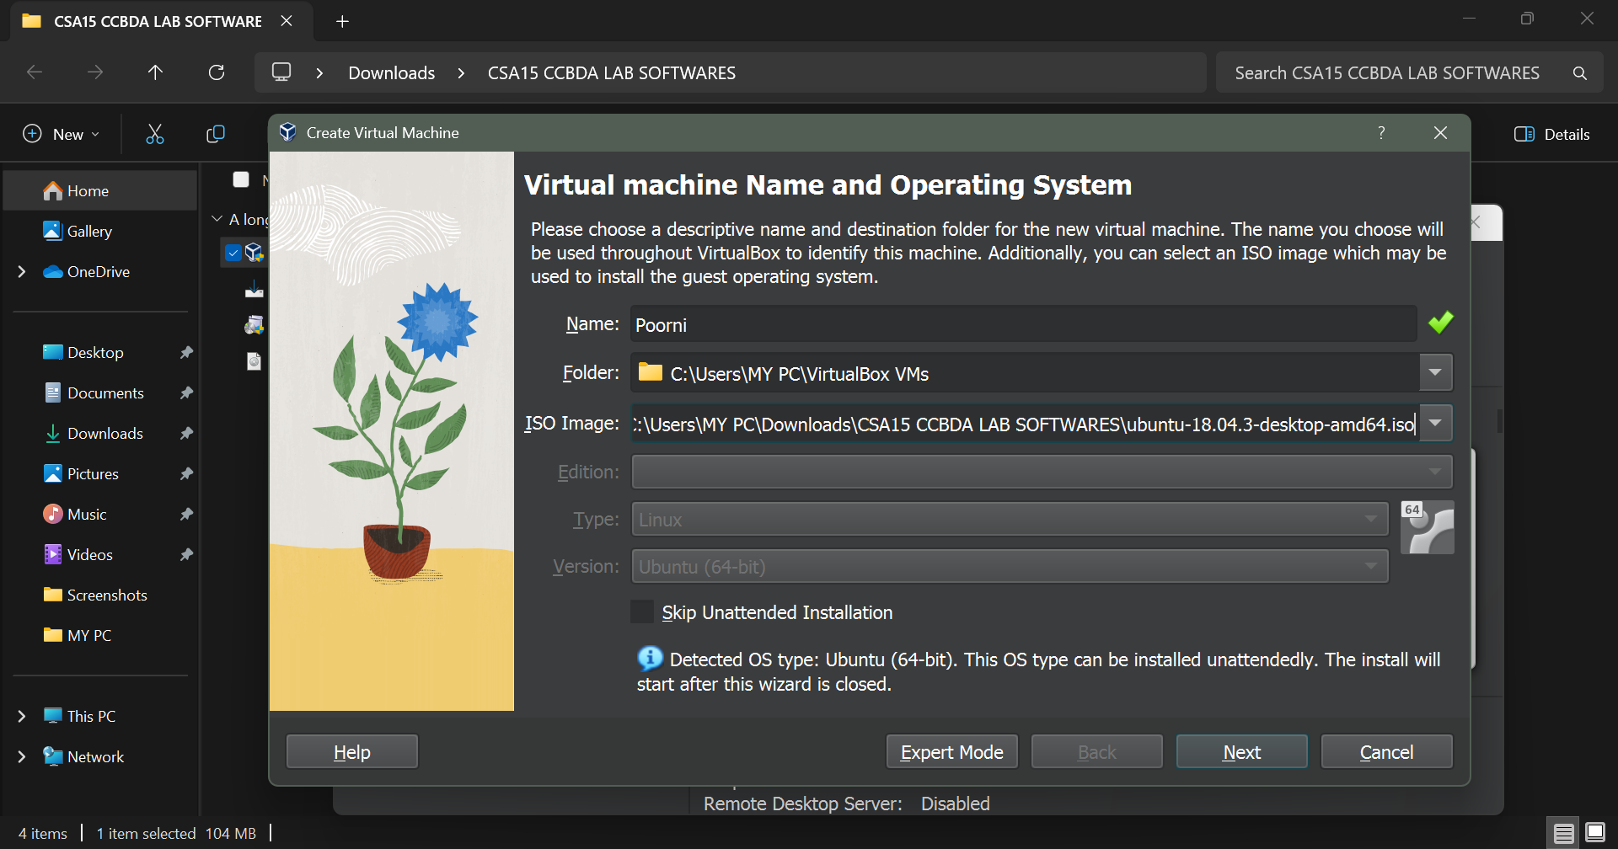

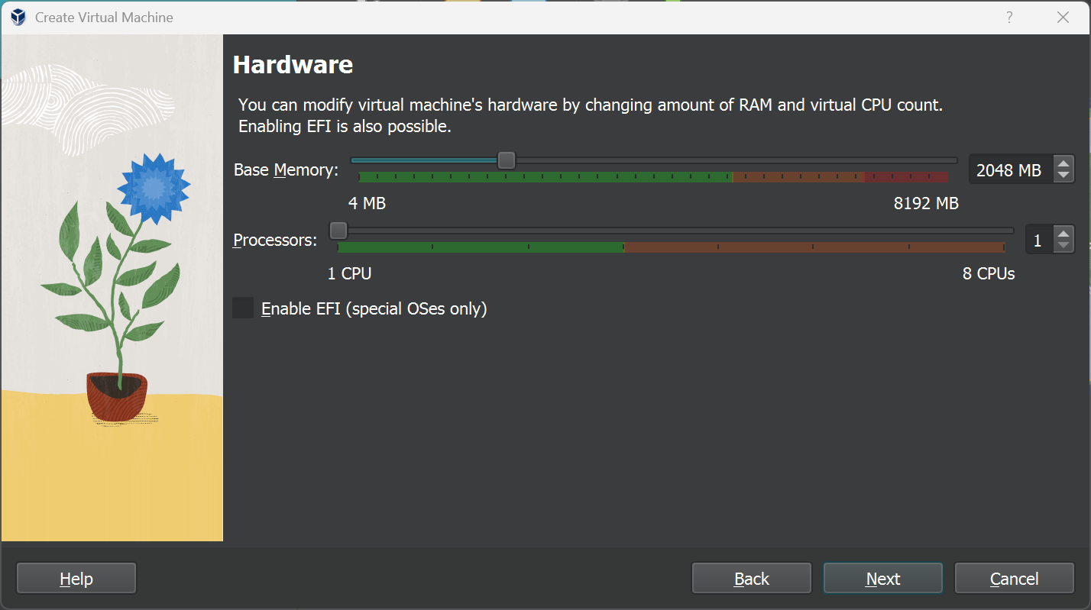

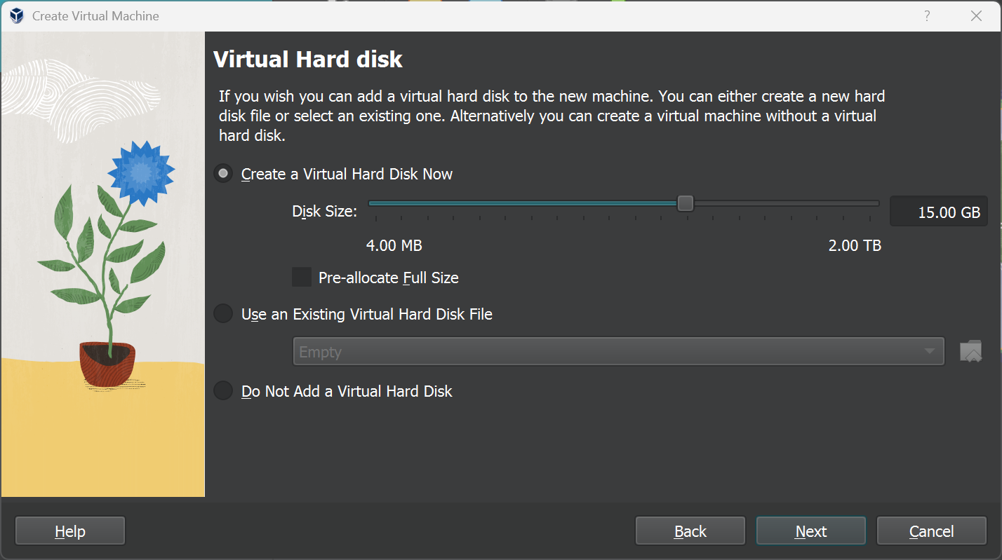

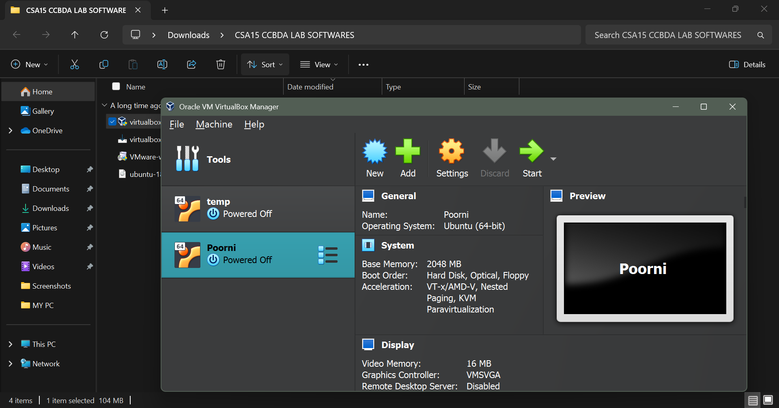

**Result:**

Thus the virtual machine was created and run successfully